**43 BEVERAGE DRIVE, TULLAMARINE VIC 3043**

**PH: 03 9330 4466 FAX: 03 9310 5788**

[**www.chatterton.com.au**](http://www.chatterton.com.au)

**\*SPECIALS VALID FROM THE 1ST OF AUGUST– 31ST OF AUGUST 2018\***

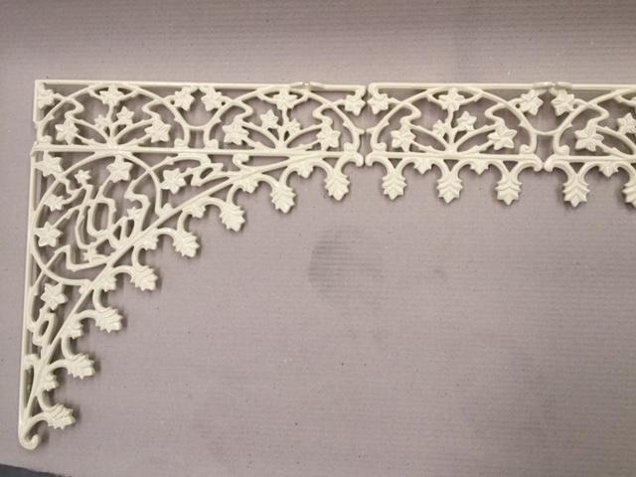

**BARRINGTON LACE - MILL FINISH**

**- CORNERS AND FRIEZE $25.00EA PLUS GST**

**CANTERBURY BELLE LACE - MILL FINISH**

**- CORNERS $26.00EA PLUS GST**

**- FRIEZE $25.00EA PLUS GST**



**KENSINGTON LACE - MILL FINISH**

**– CORNERS $20.00EA PLUS GST**

**- FRIEZE 18.00EA PLUS GST**



**SMALL CLOVER LACE - MILL FINISH**

**– CORNER $26.00EA PLUS GST**

**- FRIEZE $25.00EA PLUS GST**



**WESTMINSTER CORNER - MILL FINISH**

**$32.00 EA PLUS GST**

**RECEIVE FREE POWDERCOATING ON 90mm, 100mm, 120mm, 125mm POST CAPITALS.**



**B20A – 200mm POST CAPITALS MILL FINISH**

**- $110.00 EA PLUS GST**



**B54A 90mm or 100mm (sits on top of post) POWDERCOATED BLACK – FACTORY SECONDS - $40.00EA PLUS GST *LIMIT STOCK\***



**B30C – SIT ON TOP OF 100x100mm POST MILL FINISH**

**- $32.00EA PLUS GST**

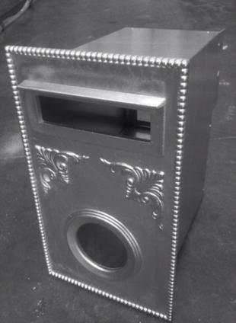

**STANDARD BRUNSWICK LETTERBOXES POWDER COATED BLACK ONLY - $150.00EA PLUS GST**